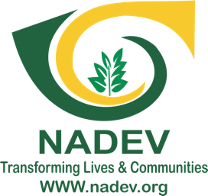

NADEV 2020
ANNUAL REPORT

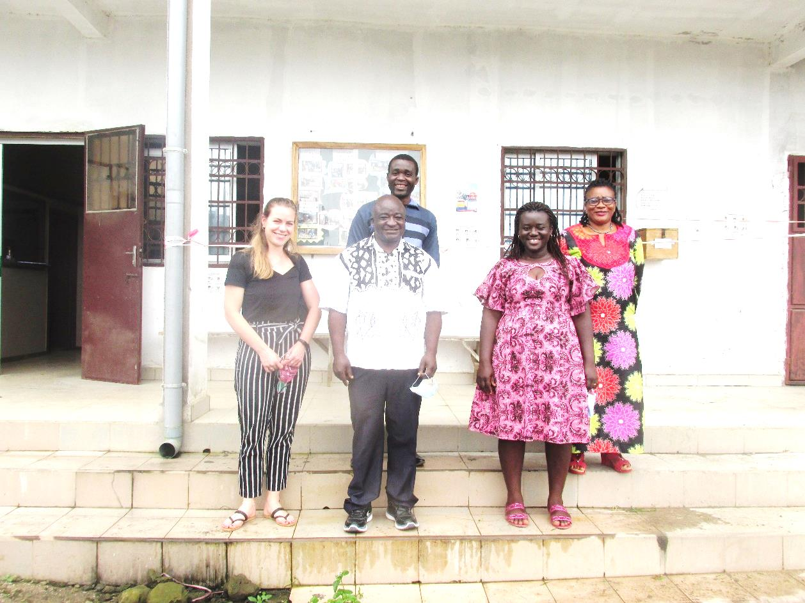

Table of Contents

Introduction …………………………………………………………………………………………………………………………………………..3
Background Information: …………………………………………………………………………………………………………………..3
Our Programs and Projects ……………………………………………………………………………………………………………………5
Promotion of Agriculture/Livelihood ………………………………………………………………………………………………….5
Entrepreneurship and Skills Development: ………………………………………………………………………………………..5
Mobilizing Savings and Delivering Micro-credit………………………………………………………………………… … 5
Water, Sanitation and Hygiene (WASH) ……………………………………………………………………………………………..5
Promoting Gender Equality ……………………………………………………………………………………………………………….6
Working with Communities on HIV/AIDS Prevention and Care………………………………………………... 6
Research and Development Services …………………………………………………………………………………………………6
Projects Under Taken …………………………………………………………………………………………………………………………….7
Piggery for Widows ……………………………………………………………………………………………………………………………7
Poultry support for widows ……………………………………………………………………………………………………………….7
Gender Based Violence Awareness Campaigns………………………………………………………………………… 8
NADEV Corona Response Projects ……………………………………………………………………………………………………..8
PROCIVIS Project ……………………………………………………………………………………………………………………………..12
Internship and volunteerism ……………………………………………………………………………………………………………13
Publication and Media Coverage ……………………………………………………………………………………………………..13
Staff capacity building ……………………………………………………………………………………………………………………..14
Trainings and meetings organised ……………………………………………………………………………………………………14
Some workshops/seminars attended ………………………………………………………………………………………………16
Sources of Funding For the Year ………………………………………………………………………………………………………….16
Partners and Networks ………………………………………………………………………………………………………………………..17
International Partners ……………………………………………………………………………………………………………………..17
Local Partners ………………………………………………………………………………………………………………………………….17
NADEV’s Office Construction ……………………………………………………………………………………………………………17
Problems Encountered During Projects Execution………………………………………………………………………… 17
Attempted solutions to some challenges …………………………………………………………………………………………….18

Introduction
Nkong Hill Top Association for Development (NADEV) Buea is a community based civil society organization which was created and registered in 1996 first of all as a Common Initiative Group (NCIG) then later metamorphosed into an Association in 2013 -Nkong Hill Top Association for Development as a process to gain a full NGO status. For 24 years now, NADEV has been working to improve the socio-economic status of the underprivileged vulnerable population especially low- income women and youths in the rural/urban settings of the South West Region of Cameroon. Working relentlessly in the area of community development and human capacity, NADEV won the first Provincial trophy for promoting women’s income generating activities awarded on the occasion of the International Women’s Day in 1999, also won the 1st prize at Provincial Agricultural Show for seed maize production in 2000. In 2009 NADEV created a financial institution called Nkong Credit for Development (NC4D) which till date has enhanced access to micro finance for over 4000 small business women and over 1500 loans to its members. The organization elaborated a 5 year Strategic plan (NADEV Vision 2020) in November 2015 with the Nkong Women Entrepreneurship Project) at the helm and the Youth category substantially added. In June 2016, NADEV celebrated its 20years of great achievements on the occasion of its 20th Anniversary. In December 2017 NADEV received an award offered by Nextel Cameroon and Youth Empowerment Actors for impact creation in Community Development. More interestingly, NADEV won the SWECSON NGO award in the domain of Business and Micro Financing. Also, NADEV’s Board member, Mercy Wangyia won the Woman of the Year award on March 8th 2018.

Background Information:
Who We Are
Our Identity
We are a hill top organization a special name and position in the South West of Cameroon. We have developed and nurtured the ability to adjust in times of crisis and become resilient. We have the ability to remain focused in our field of expertise and our credibility as a learning organization is on the rise

Our Vision
We want to see Communities that are Empowered, Sustainable and Living in Harmony.
Our Mission
We are a Cameroonian based Organisation dedicated to accompanying communities to become empowered, sustainable and living in harmony
Our Values
At NADEV, work is guided by the following:
- Equity for all
- Accountability/Transparency
- Upholding Human Dignity
- Dedication to community
- Professionalism and Learning
- Integrity
Our Goal
To improve the socio-economic status of the rural and urban underprivileged and marginalized population, especially women and youths
Our Strategic Objectives for 2016-2020
- Promote Enterprise Development
- Improve on standard of living through Sustainable Agriculture and Livelihood programs
- Strengthening NADEV’s Organizational Capacity

Our Motto: Transforming lives and communities

Our Programs and Projects
NADEV’s programs and projects include the following:

Promotion of Agriculture/Livelihood
Since 2003, in partnership with the National Employment Fund (NEF), NADEV supports farmers to increase production and productivity through trainings and in kind credit. Projects have been carried out in Fako, Lebialem and Kupe-Muanenguba Divisions.
Apart from these NADEV also supports widows to create piggery farms to improve nutrition as well as income generation.

Entrepreneurship and Skills Development:
Through the Nkong Women Entrepreneurship Project (NWEP), over 4000 low income women have been trained on Small Business Management in five out of six Divisions in the South West Region. In 2016 NADEV launched the Nkong Youth Entrepreneurship Program which has led to the training of 200 youths on Entrepreneurship.

Mobilizing Savings and Delivering Micro-credit
NADEV started as a weekly savings club in 1996. Over the years the organization developed the Nkong Women Cash up (NWOCA) product through which it has continued to grant micro credits to low income women for small business promotion.
Over 4000 women have been financed thanks to our enduring partnership with All We Can, UK. Due to the rapid expansion of this scheme, NADEV created a stand-alone accredited and fully regulated Micro Finance Institution – Nkong Credit for Development (NC4D) in 2009. By 2017 NC4D had eight branches in Buea (Mile 17 and Great Soppo), Mutengene, Kumba, Bonaberi- Douala, Muyuka, Munyenge, Menji. However, due to the crisis operations in 3 of these branches found in the red zone have been suspended with one new created in Dschang to serve the Lebialem migrant population there in.

Water, Sanitation and Hygiene (WASH)
In partnership with the Netherlands Development Organization (SNV) NADEV has assisted 23 Municipal Councils in the South West Region to implement the Rural Water and Sanitation Project (PAEPA-MRU) involving the construction of ventilated improved pit latrines for both public and private institutions like schools, markets, dispensaries and private poor households. With the support of Peace Corps Cameroon and KOICA respectively, NADEV constructed VIP Latrines for GSS Maumu in the outskirts of Buea and GSS Ediki in Meme Division. Worthy of note is the construction of latrines slaps for 13 households in Maumu village with Cameroon Government subvention. NADEV is currently mobilizing funds aimed at address this precarious and widespread need in the Region.

Promoting Gender Equality
NADEV’s Women Empowerment Program has been active in several domains to bring about gender equality. As a policy, gender balance issues are integrated in all NADEV’s programs.
Our current focus is on Gender and widows Rights. Sensitization workshops have been organized in over 50 communities in the Region and exchange visits organized with chiefs to improve on the status of women in general and widows in particular.

Working with Communities on HIV/AIDS Prevention and Care, Promotion of Sexual Reproductive health.
NADEV launched its Participatory HIV/AIDS Control Program (PHACOP) in 2002. Several projects were delivered under the program. In 2015 NADEV partnered with CARE Cameroon to ensure improvement in the quality of care at treatment Centers while developing the capacity of Community based groups of people living with HIV/AIDS under the Initiative 5% Project. With the support of All WE Can NADEV went into community sensitization on the impact of teenage pregnancy on girls and the society at large.

Research and Development Services
NADEV offers services to partners for Studies, Participatory Planning, Impact Evaluations, Diagnostic Surveys, Institutional Assessments, and Capacity Building. Partners who have recently chosen NADEV services include the PNDP, UNDP, GIZ PSMNR, Rumpi, FODECC, PARI, ONEXPALME, and the NEF.
We also have space and Equipment for training and meetings at our new head office in Molyko, Buea.
Projects Under Taken
The dominant project for the year 2020 at NADEV was the

Piggery for Widows
By implementing activities of NADEV’s Operational Plan year 5, more 15 widows were supported in the Buea,Melong and Santchou in Fako, Menouaand Moungo divisions respectively. As per the project, each widow received a backyard pigsty, training on modern pig farming, supply of two piglets and vaccines, feed, and technical assistance for six months.
Mami Beatrice who was supported in 2020 and based in Sandpit-meeting pointBuea was paid a friendly visit by NADEV to get an insight of her so far. She said. On February 2021 Mami Beatrice sow farrow 08 very healthy piglets. Upon separating the piglets from their mother, she sold 02 of the piglets for 50,000 FRS and the mother for 100,000 FRS. She then used the proceeds to do some renovations in her house.
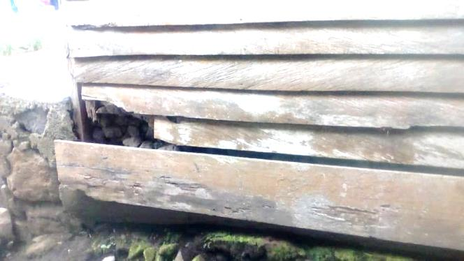
“NADEV helped me pass through a very difficult time in my life. Through this project, I was given 2 piglets male and female. My piggery redefined my purpose and gave me reasons to work harder she said. “I took very good care of me piglets and they grew big and healthy. I succeeded in crossing the male and female pigs and shortly after I sold the boar for 80.000 FRS and the money was used to pay my children’s fees”.
…“I have parched up the roof, bought new planks and sand to renovate the walls and foundation of my house. Now I can invite people to my compound freely”
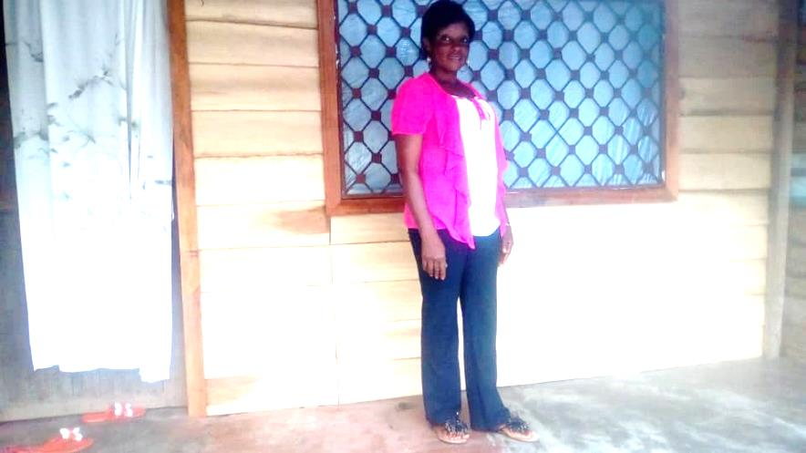
… “Words alone cannot express how grateful I am for the support given to me by NADEV through this project. I look forward to taking very good care of my reminding 06 piglets for the betterment of my family. I pray God Almighty continues to bless the entire NADEV family. Before renovation
Before renovation

Afterrenovation

Poultry support for widows
Fromthe successes that the poultry project witnessed in the year 2019, NADEV in its Operational Plan year 5 (2020) increased the number to 30. Five widows benefited in Bokwai village, 11 in Small Soppo, 05 in Mudeka village, 4 in mile 4 Bonadikombo and 5 in Motombolombo. In the course of project execution each widow were provided02drinkers, 03 feeders, 100three week old chicks and 450kg of composed fowl feed.
AnwiTahJustina, a 53 years old widow who live in Wututu road Mile 4 Bonadikombo villageis delighted to share her story.
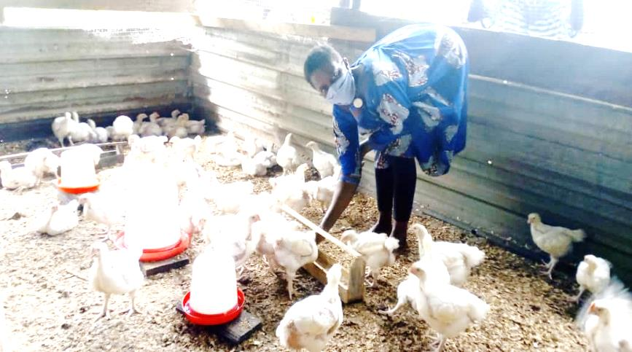
‘’Since the death of my husband, my seven children and I lived in my husband’s family compound with his other brothers and their families. I could not meet up with providing my children;s school needs which made some of them to drop out from school. We have been struggling to survive. I heard about NADEV from our women group leader through the chief who invited us to the palace when NADEV visited our village. Fortunately,
Mami Justina at her poultry
I was selected by NADEV’s field staff and supported in the two phases with 100 three week old chicks, three feeders, two drinkers, 400kg of fowl feed and drugs for the treatment of the birds. At the end of mysales (02 phases) I was able to realize 336,000FCFA. With this money, Irenovated the leaking roof of our house, rented a piece of land to cultivate food crops from which sales I was able to complete school fees for my children. Also throughout this period, my children were very excited to eat delicious protein rich meal from chicken meat. Today I am a very happy mother because through NADEV support I was able to achieve a lot of things and my life is heading for better days ahead.”

Gender Based Violence Awareness Campaigns
As a means of reducing violence against women and upholding women’s right, NADEV carried out 13 sensitization workshops in Fako, Moungo and Menoua Divisions. These workshops were aimed at sensitising the population on the ills of Gender Based Violence (GBV) thereby reducing itsoccurrence. Topics treated during such workshops were; what is gender, sex, GBV, types and causes of violence, causes of GBV, it effects, sanctions on GBV according to the Penal Code and the different GBV referral pathways in the Region.

Beneficiary responding to a question during GBV sensitization in Mile 4 limbe

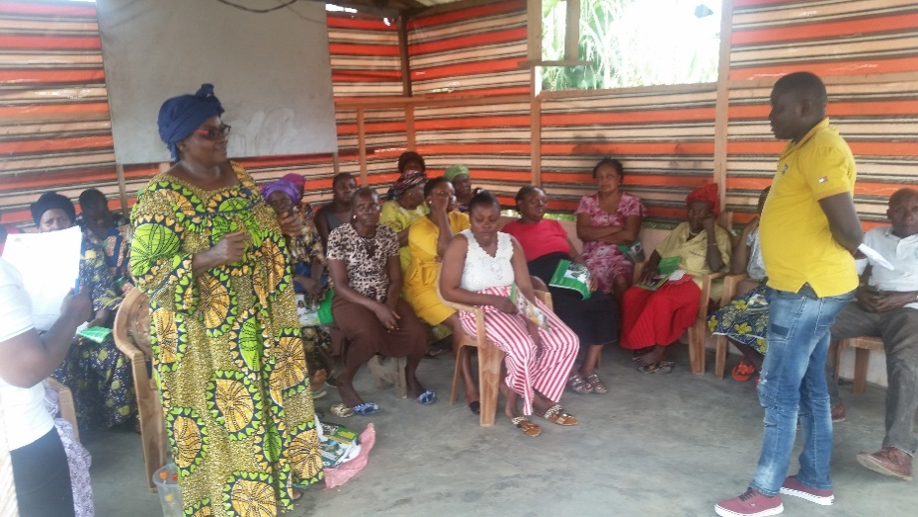

NADEV Corona Response Projects
With the emergence of the COVID-19 pandemic NADEV implemented 04 phases of Corona Response projects within its 2020 Operational Plan. The projects wererolled out as follows:
Phase 01: Buea, Tiko, Limbe 1 &Limbe 2
Phase 02: Buea, Tiko, Idenau, Mundemba, Nkongsamba 2eme &melong
Phase 03: Buea, Tiko&Limbe 2
Phase 04: Buea, Tiko&Limbe 2
Phases 01 & 02 had the same objective which was; toimprove public hygiene and safety practices so as to reduce the spread of the Corona pandemic in the South West Region. Through the above mentioned phases, NADEV was able to reached 24 communities via sensitization in pidgin English and French with the use of mega phones in marketsand other gatherings thus reaching a population of 136,000 people. Also, 4000 posters and 2500 stickers were produce and pasted in the communities to remind inhabitants about the prescribed measures. NADEV equally set up 20 hand washingstations with buckets and 96tippy taps in the different communities. The tippy tap was very much welcome in all the communities because it is less costly and easy to replicate. For continuous improvement of hygiene, 10 demonstrations on preparing hand sanitizers was carried out in 32 communities and 8000 face masks shared to staff, community relays and vulnerable persons in communities.
Installation and demonstration on how to use a tippy tap in Misselele village
Community sensitization in Melong
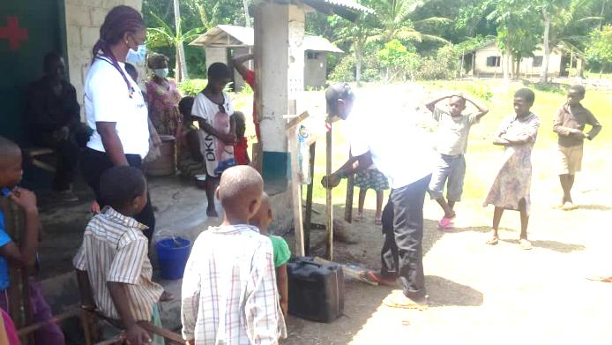
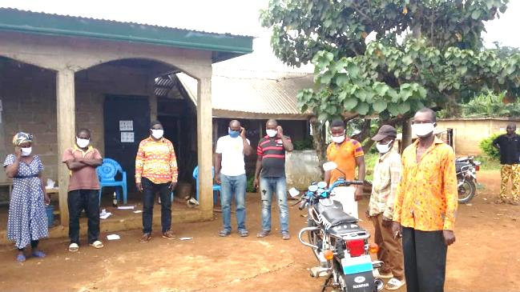

Phase 03 of the corona Response project had as objectives;
- To stop the spread of Covid-19 among the population.
- To encourage the population to apply prescribed measures to reduce the spread of Covid-19.
- To build capacity of communities to combat Covid-19.
The following activities were implemented for this phase;
- 03 councils (Buea, Tiko&Limbe II) and 10 NADEV staff were trained on for Behavior Change Communication
- Carried out mass media sensitization with over 66 radio spots in 04 radio stations.(CBS, Eden, Tiko Council Community and Bonakanda radio stations)
- Sensitized and distributed face mask, hand sanitizers and disinfectants to call 100 box operators (75 women and 25 men)
- Sensitized 50 taxi drivers and their syndicate on the importance of adhering to the barrier measures and distributed sanitary kits (facemasks, hand sanitizers & disinfectants).
- Draw up 05 community Covid-19 response plans for Limbe 02 Council
- Installed 100 tippy taps in communities
- Adapted, printed and distributed 200 copies of story book "My Hero is You”to 12 schools and 03 churches (in Limbe, Tiko and Buea Municipalities) reaching a population of 1500 pupils for both the school and churches. Children/pupils acquire and share knowledge on Covid-19 issues while in school and in their homes.
Distribution of sanitary kits to a call box operator
Distribution of sanitary kits to taxi drivers
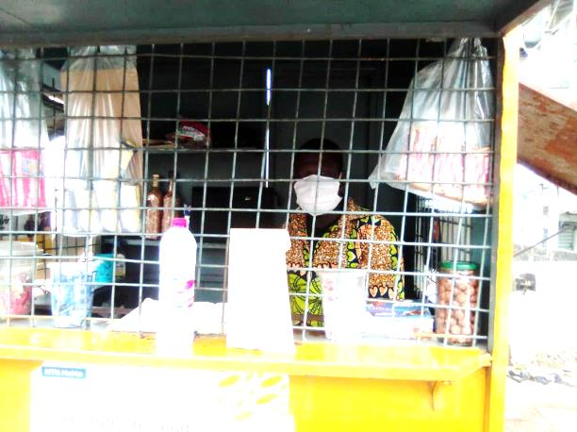
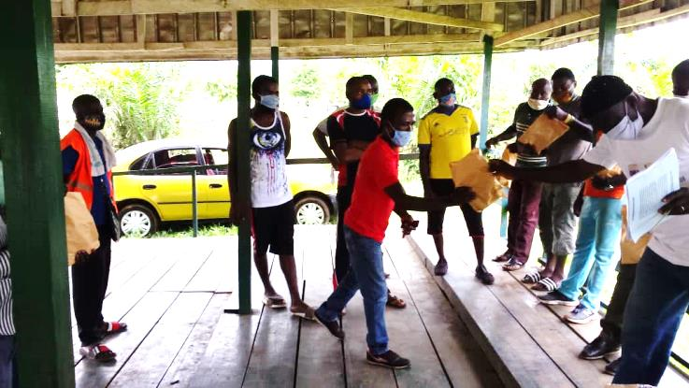

Due to the negligenceof the population inpracticing the barrier measures of Covid-19, NADEVcalled to consciousness the populationthrough it Corona Response project 4 with objective;Enhance Community Engagement to reduce the spread of Covid-19. This phase started with a capacity building workshop on Behaviour Change Communication (BCC)for 12 media practitioners (Radio and TV) to mainstream Covid-19 Prevention Strategies in their radio/television Programmes. Spots on back to school and voluntary testing were produced in pidgin English, English and Bakweri languages and aired over these radio stations (Mediafrik, Divine Mercy, Dream FM, Bonakanda, CBS, CBC, Eden, Ocean City and Tiko Community). A back to school television spot was produced and broadcast over Legacy television. Feedback from the audience of these radio stations say the message is short, simple, appealing and easily understood. Also, message is coming at a time to reawaken the population. Added to the above, these other activities were carried out;
- Carried out sensitisation around kiosks and motor parks while pasting stickers (300)in Buea, 200 in Mutengene and Tiko, 150 in Limbe.
- Distributed COVID-19 Sanitary kits to 300 Kiosk operators (253 female /47 male) and 80 drivers in Limbe II, Tiko and Buea municipalities.
- Printed and distributed 850 copies of Covid-19 story book My Hero is You to pupils in 30 schools alongside reusable face masks. Pupils are aware of Covid-19, the measures and how to prevent themselves from it.
- Supported Limbe II Council to organise a stakeholder meeting during which an action plan for 2 weeks was adopted to distribute masks, sanitizers and soap in schools in the municipality.
- Organized a two day workshop in Tiko and Limbe II on mainstreaming Behaviour Change Communication into youths’ engagement as one of the instruments for COVID-19 prevention.
- From their request, NADEV distributed food items and Covid-19 Sanitary kits to 120 IDPs in the Buea, Tiko and Limbe II municipalities.
Storybook distribution in GPS NdongoBuea
Brainstorming of journalist during an exercise
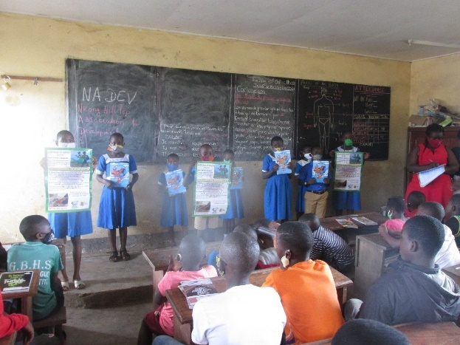
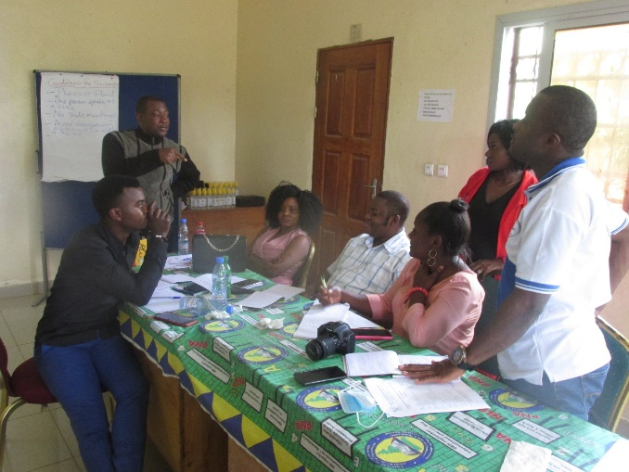

Active Citizenship Strengthening Program
In order to increase public access to civil status documents in Cameroon due to the alarming rate of negligence and ignorance of some citizens on the importance of civil status documents (Birth certificates, Marriage certificates, and Death certificates) and the procedures to acquire them, NADEV came in partnership with the European Union in a project entitled Active Citizenship Strengthening Program with it French acronym; PROCIVIS. NADEV as a local partner had as mission;
- To sensitise the project stakeholders, beneficiaries, and the local populations on the importance of civil status documents and the procedures to acquire them.
- To accompany vulnerable persons in the process of acquiring these important documents.
This project that started in December 2019 on going is implemented in Bonalea, Mbanga, Penja, Loum, Nkongsamba 2eme and Melong Councils of the Moungo Division. The project was launched in all the above-mentioned Municipalities and had representatives from MINAT, MINDDEVEL, MINPROFF, MINAS, MINEDUB and MINSATE. Also, Mayors, Secretaries Generals and Civil Status centres, officers of secondary civil status centres, heads of youths and women associations were also present. The project had as target to establish 3000 birth certificates, 500 marriage certificates, and 100 death certificates.
To foster sensitization, NADEV organised several exchange visits with participants on the procedures to establish the target documents, difficulties encountered and way forward. During these visits, participants highlighted difficulties encountered by service users such as; lack of mastering of the procedures to establish civil status, some grandparents do prevent the biological fathers of the new born babies from recognizing their children, some couples find it difficult to agree on the marital regime, some think death certificates are for those who worked with the government. Again, through the principal stakeholders, NADEV identified 12 community relays in each municipality and trained (six workshops one for each sub division) them on the project, role of sensitization and data collection. These community relays with NADEV staff continued in the sensitization by pasting posters in English and French carrying information on the procedure to establish a birth certificate from the date of birth in health Centres and other strategic places. Furthermore, sensitization spots were produced, circulated over social media, and played over Nkongsamba FM for a period of one month.
In the course of monitoring and evaluation, the situation is improving notably in the numbers of spontaneous declarations of births, marriages and deaths, more and more persons have been calling our field agents to inquire on the various procedures, some councils e.g. Melong council has instituted the principle of parents phone number first in every birth declaration, the rate of recovery of abandoned birth certificates in the NgalMbo centre has drastically increased.

Launching of Procivis project in Nkongsamba 2eme Council
Training of civil status registers and others concern with civil status documents

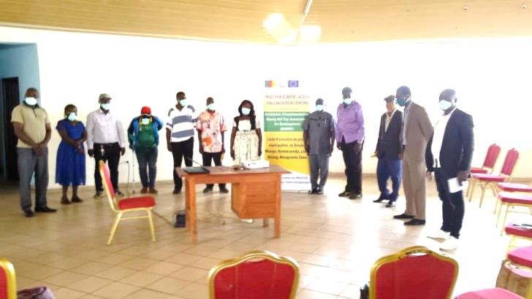
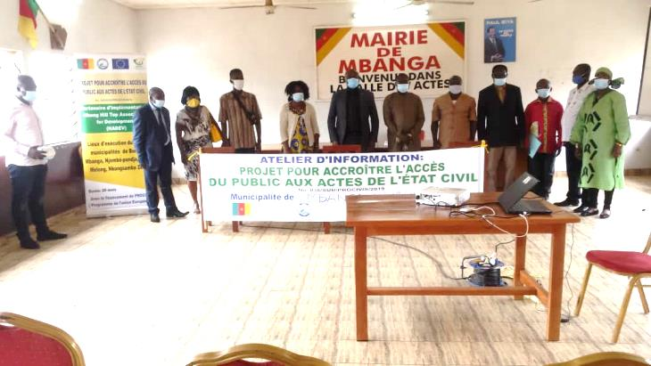

Internship and Volunteerism
NADEV had 01 volunteer and08 interns from the University of Buea. 02 from the Department of Public Administration, 03 from the Department of Women and Gender studies and 03 from the Department of Sociology and Anthropology. They assisted in the implementation of the Corona Response Projects by distributing the COVID-19 story book to schools, sensitized and distributed face masks, hand sanitizers and disinfectants to call box operators and follow up of those sensitized. Through these projects, most of the interns attest that their objectives were met via the many trips they did. Thus they had an in-depth knowledge of project management, implementation, report writing and different perspectives of people on the corona virus.

Publication and Media Coverage
For the first time NADEV launched its E-Newsletter which has replaced The Nkong Development Insights. The E-Newsletter was shared among friends and partners to keep them abreast with activities of NADEV. NADEV developed 69 radio spotsthrough its Corona Response Projects on safe back to school, community sensitization on the barrier measures, voluntary testing and an encouragement to parents to send their children to school. These spots were aired over some radio stations in Fako Division such as CBS, Divine Mercy, Media Afrik, Dream FM, Bonakanda, CBC, Ocean City, Eden and Tiko community radio.These spots were aired in pidgin English,English and Bakweri languages. Also, a safe back to school TV spot was developed and broadcast weekly over legacy Television (LD TV). Again, 04 radio spot sensitizing the population on the importance ofcivil status document was broadcast over some radio stations in Moungo Division. Articles and pictures of NADEV’s field activities were frequently published on social media sites such as the TV, NADEV Website, Facebook and Twitter.

Staff capacity building
Staff of NADEV had a training on advanced Exceland SPSS facilitated by Straw Academy. This training was aimed at improving their skills on data entry, analysis and to work with Excel effectively and efficiently.
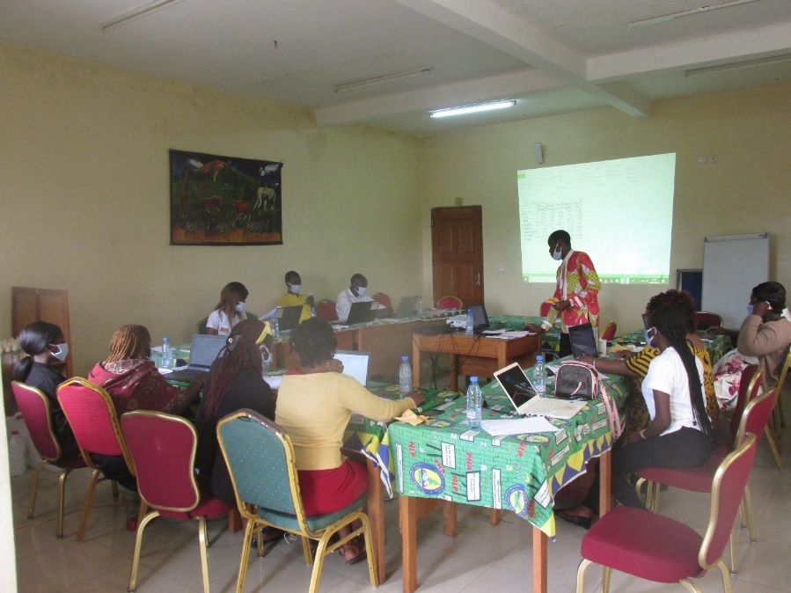
NADEV Staff and interns during training

Trainings and meetings organised
Workshops | No organised | Persons reached | Location
Modern pig farming | 03 | 15 | Buea, Melong&Santchou
Poultry farming | 05 | 30 | Bokwai, Small Soppo, Mudeka, mile 4 Bonadikonbo and Motombolombo
Sensitization on Gender and Widows Rights | 13 | 721 | New Bonako, NkongsambaLemlem, Mbanga, Mile 4 Bonadikombo, Small SoppoWovia, Long Street Wonganga, Loum. Nkongsamba 11, Penja, Njombe, Bonalea and NgayaSantchou,
PROCIVIS | 12 | 172 | Bonalea, Mbanga, Penja, Loum, Nkongsamba 2eme and Melong
Corona Response Project | 10 | 144 | Buea, Limbe (Batoke, Mokindi, Botaland and Isokolo), Tiko (Ekange, Water tank, Upper Custain, Newlayout, Ndongo camp and Long Street)

Some workshops/seminars attended
Date | Venue | Organizer | Thematic concern
September 2020 | Eta Palace Hotel | Reach Out | Hate Speech
11/09 2020 | Centre for Human Right and Democracy in Africa (CHRDA) | CHRDA | Human Right CSOs and setting up of early warning system
January 2020 till present | Online zoom meeting | OCHA | Education Cluster meeting
May 2020 | Reach Out | Reach Out | Finance law Amendment in the midst of Covid-19
08/07/2020 | Regional Delegation of Communication | Regional Delegation of Communication in Partnership with Regional Delegation of Public Health | South West Multi Sectoral Task Force to fight Covid-19
August 2020 | LUKMEF | LUKMEF and UN Women | Mainstreaming gender in the Covid-19 context
May 2020 | Online zoom meeting | OCHA | Food Security Cluster meeting

Sources of Funding For the Year
NADEV runs its activities thanks to the following sources of financial and technical support:
- Membership Contributions
- Income generated from Consultancy Services
- Savings
- Subvention from MINSANTE for health activities
- Support from International and local Partners

Partners and Networks

International Partners
  - All We Can Methodist Relief and Development, England
  - Associated Country Women of the World (ACWW) London
- CIVICUS
- UNDP
- The People of Japan
- Street Child

Local Partners
- MINADER
- MINPROFF
- MINEPAT/PNDP
- MINAS
- MINSANTE
- SWECSON

NADEV’s Office Construction
The building haS been completed and given out for rents.

Problems Encountered During Projects Execution
- Insecurity due to current Anglophone crisis.
- Poor M&E done in some villages in red zones
- Increase expectations of beneficiaries and communities.
- Financial expectations of government officials prior to partnership.
- Covid-19 breakout and government decision close down offices for some period hindered field work.

Attempted solutions to some challenges
- Calls were made frequently to follow up beneficiaries.
- Online zoom meetings were held
- Activities were carried out earlier than the anticipated time.

